Problem Statement: Stepwise Execution Analysis of Sorting Algorithms I

Bubble Sort
Theory:
Algorithm (Step-by-Step):
- Repeat for i = 1 to n − 1:
- Set swapped = false.
- For j = 1 to n − i:
  - If A[j] > A[j+1], swap them and set swapped = true.
- After the inner loop ends:
  - If swapped == false, break (array is already sorted).
- Otherwise, increase i and continue.
- Finally, the array is sorted.
Bubble Sort Flowchart Layout:
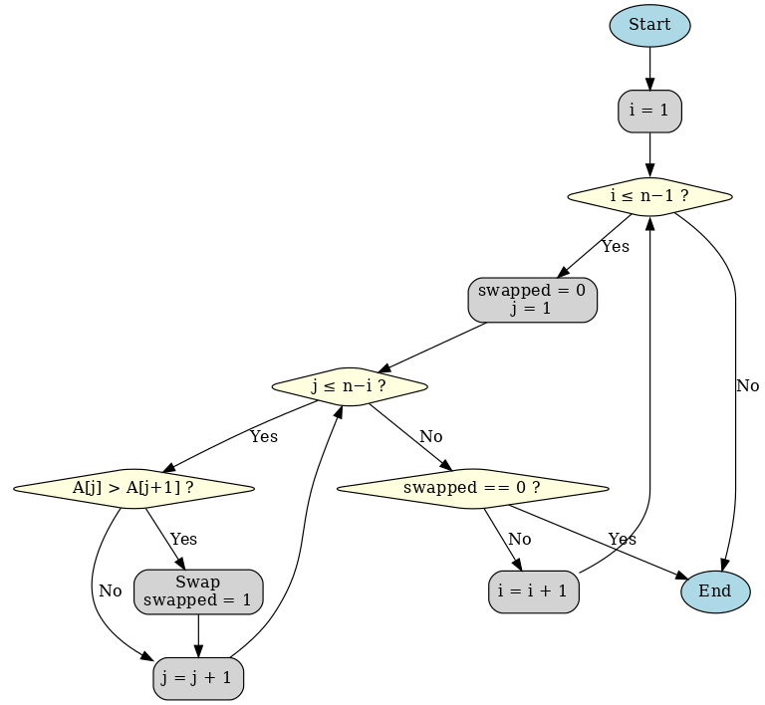

Code:
#include <iostream>
using namespace std;

void bubbleSort(int arr[], int n) {
bool swapped;
int c1, c2;

for (int i = 0; i < n - 1; i++) {
swapped = false;
for (int j = 0; j < n - i - 1; j++) {
c1++;
if (arr[j] > arr[j + 1]) {
int temp = arr[j];
arr[j] = arr[j + 1];
arr[j + 1] = temp;
swapped = true;
c2++;
}
}
if (!swapped)
break;
}
cout << "Number of Comparisn: " << c1++ <<endl;
cout << "Number of Swapping: " << c2++ << endl;
}

int main() {
int n;

cout << "How many elements there?: ";
cin >> n;

int* arr = new int[n];

cout << "Enter elements: ";
for (int i = 0; i < n; i++) {
cin >> arr[i];
}

bubbleSort(arr, n);

cout << "Sorted array:\n";
for (int i = 0; i < n; i++) {
cout << arr[i] << " ";
}
cout << endl;

return 0;
}

Screenshots:
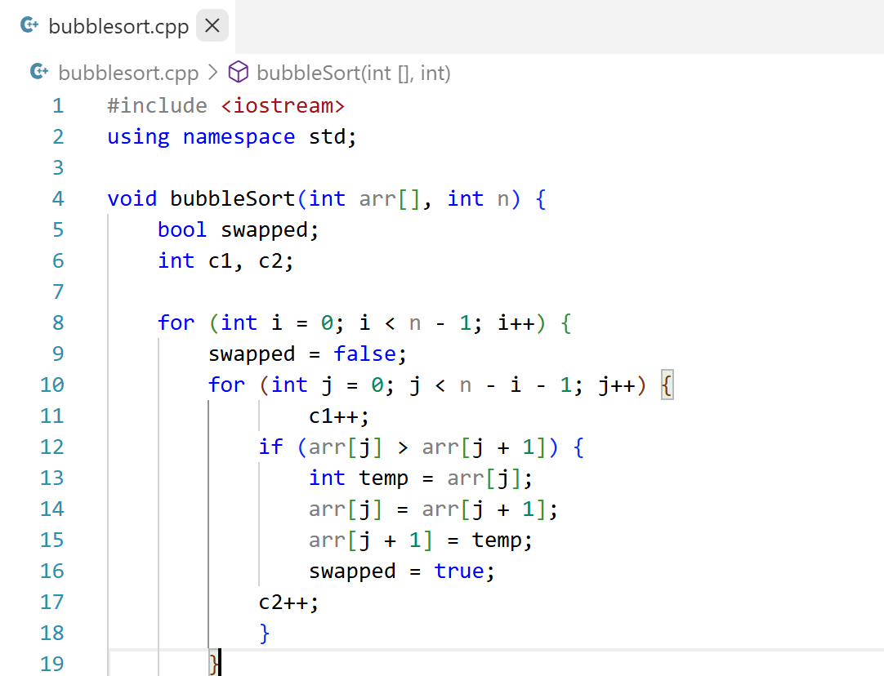
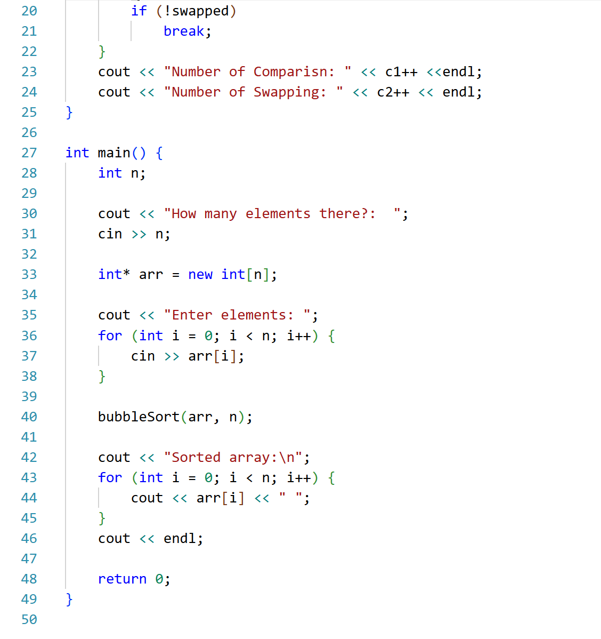

Output:
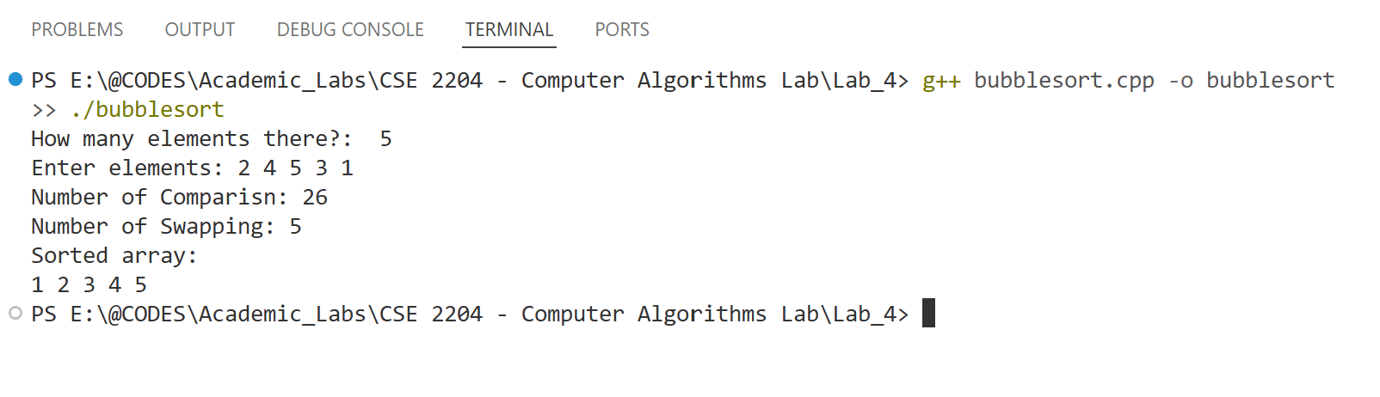
Analysis:
We will trace the Bubble Sort algorithm step by step to see how it processes the input data and arrives at the final sorted array.
Input Array: A = [2, 4, 5, 3, 1]
Stepwise Execution (Pass by Pass):
Pass 1 (i = 1):
- Compare 2 and 4 → no swap → [2, 4, 5, 3, 1]
- Compare 4 and 5 → no swap → [2, 4, 5, 3, 1]
- Compare 5 and 3 → swap → [2, 4, 3, 5, 1]
- Compare 5 and 1 → swap → [2, 4, 3, 1, 5]
Pass 2 (i = 2):
- Compare 2 and 4 → no swap → [2, 4, 3, 1, 5]
- Compare 4 and 3 → swap → [2, 3, 4, 1, 5]
- Compare 4 and 1 → swap → [2, 3, 1, 4, 5]
Pass 3 (i = 3):
- Compare 2 and 3 → no swap → [2, 3, 1, 4, 5]
- Compare 3 and 1 → swap → [2, 1, 3, 4, 5]
Pass 4 (i = 4):
- Compare 2 and 1 → swap → [1, 2, 3, 4, 5]
Final Sorted Array: [1, 2, 3, 4, 5]
Performance Summary:
- Number of Comparisons = 26
- Number of Swaps = 5

Selection Sort
Algorithm (Step-by-Step):
Repeat for i = 0 to n − 2:
- Set min_index = i.
- For j = i+1 to n − 1:
  - If A[j] < A[min_index], then set min_index = j.
- If min_index != i, then swap A[i] and A[min_index].
- Increase i and continue.
Finally, the array is sorted.

Bubble Sort Flowchart Layout:
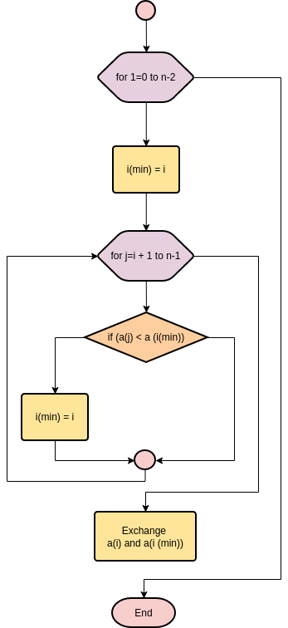

Code:
#include <iostream>
using namespace std;

void selectionSort(int arr[], int n) {
int c1 = 0;
int c2 = 0;

for (int i = 0; i < n - 1; i++) {
int min = i;
for (int j = i + 1; j < n; j++) {
c1++;
if (arr[j] < arr[min]) {
min = j;
}
}
if (min != i) {
int temp = arr[i];
arr[i] = arr[min];
arr[min] = temp;
c2++;
}
}

cout << "Number of Comparisons: " << c1 << endl;
cout << "Number of Swaps: " << c2 << endl;
}

int main() {
int n;

cout << "How many elements?: ";
cin >> n;

int* arr = new int[n];

cout << "Enter elements: ";
for (int i = 0; i < n; i++) {
cin >> arr[i];
}

selectionSort(arr, n);

cout << "Sorted array:\n";
for (int i = 0; i < n; i++) {
cout << arr[i] << " ";
}
cout << endl;

delete[] arr;
return 0;
}

Screenshots:
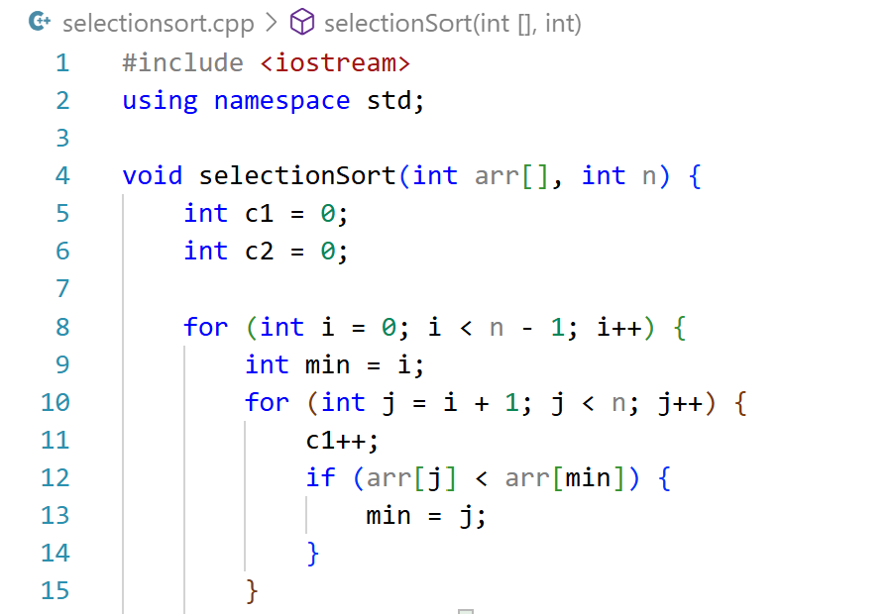
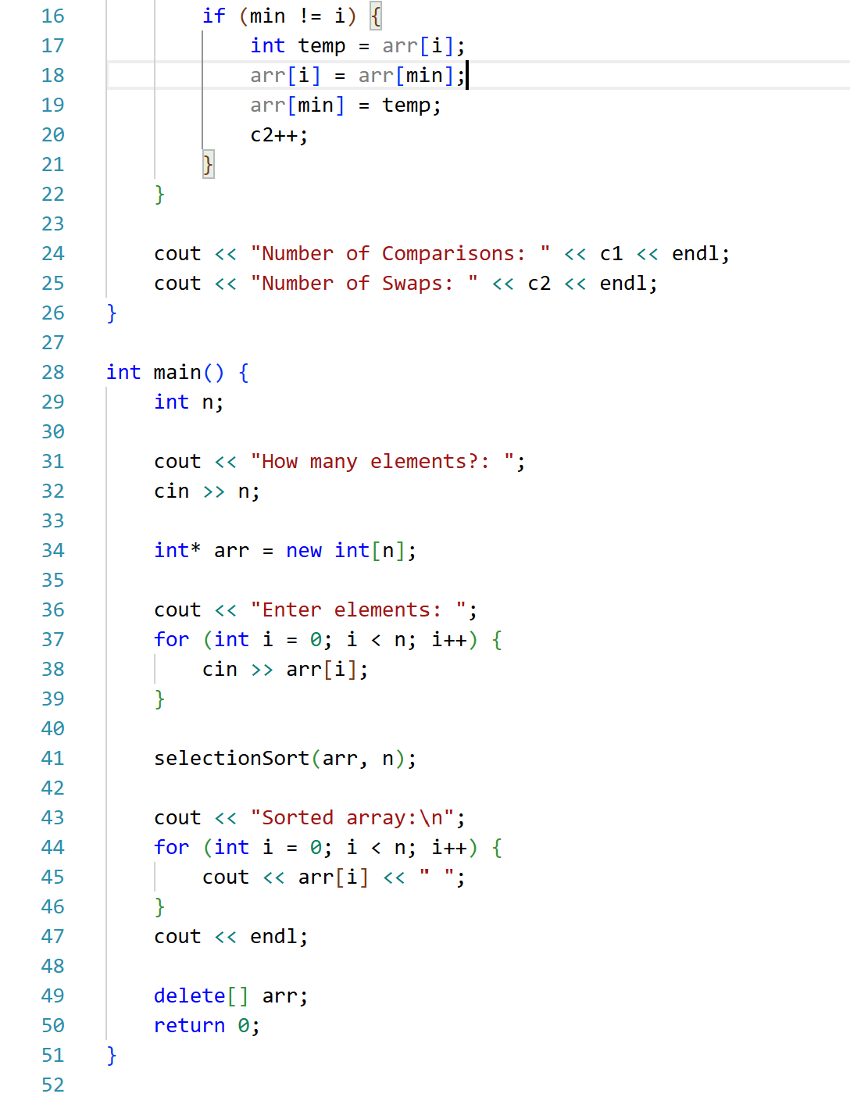
Output:
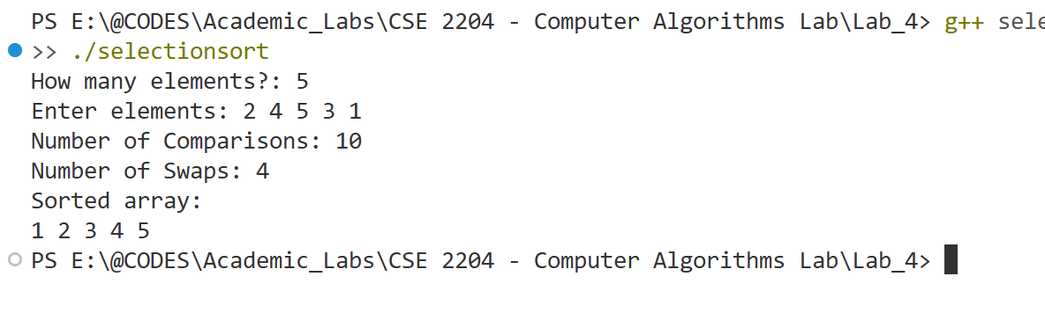
Analysis: Here, we trace the algorithm line by line to see how it processes data and arrives at the result.
Input Array: A = [2, 4, 5, 3, 1]
Stepwise Execution (Pass by Pass):
Pass 1 (i = 0):
- Compare 2 and 4 → no change → [2, 4, 5, 3, 1]
- Compare 2 and 5 → no change → [2, 4, 5, 3, 1]
- Compare 2 and 3 → no change → [2, 4, 5, 3, 1]
- Compare 2 and 1 → min = 1 → swap → [1, 4, 5, 3, 2]
Pass 2 (i = 1):
- Compare 4 and 5 → no change → [1, 4, 5, 3, 2]
- Compare 4 and 3 → min = 3 → [1, 4, 5, 3, 2]
- Compare 3 and 2 → min = 2 → swap → [1, 2, 5, 3, 4]
Pass 3 (i = 2):
- Compare 5 and 3 → min = 3 → [1, 2, 5, 3, 4]
- Compare 3 and 4 → min = 3 → swap → [1, 2, 3, 5, 4]
Pass 4 (i = 3):
- Compare 5 and 4 → min = 4 → swap → [1, 2, 3, 4, 5]
Final Sorted Array: [1, 2, 3, 4, 5]
Performance Summary:
- Number of Comparisons = 10
- Number of Swaps = 4

Observation Table
Test Case No. | Input Size (n) | Number of Comparison |  | Number of Swap/Shift |  | Execution Time
 |  | Bubble Sort | Selection Sort | Bubble Sort | Selection Sort | Bubble Sort | Selection Sort
01 | 10 (Best) | 17 | 45 | 0 | 0 | 3.627 s | 8.716 s
02 | 10 (Average) | 43 | 45 | 13 | 7 | 2.602 s | 2.713 s
03 | 10 (Worst) | 53 | 45 | 45 | 5 | 2.758 s | 2.142 s
04 | 100 (Best) | 107 | 4950 | 0 | 0 | 3.391 s | 3.671 s
05 | 100 (Average) | 4439 | 4950 | 2091 | 93 | 3.062 s | 2.885 s
06 | 100 (Worst) | 4958 | 4950 | 4950 | 50 | 13.606 s | 3.149 s
07 | 1000 (Best)
08 | 1000 (Average)
09 | 1000 (Worst)

Conclusion: Write a brief conclusion stating for what kind of data and when it is suitable to use selection/bubble/insertion sort algorithms.

